ADSD HW8 MongoDB ToDo

In this assignment I will MongoLab online mongo database as storage. It provide free 500MB space for mongo db.

You can visit from [changcode.pythonanywhere.com](http://changcode.pythonanywhere.com/) to test CRUD operations.

Pythonanywhere:

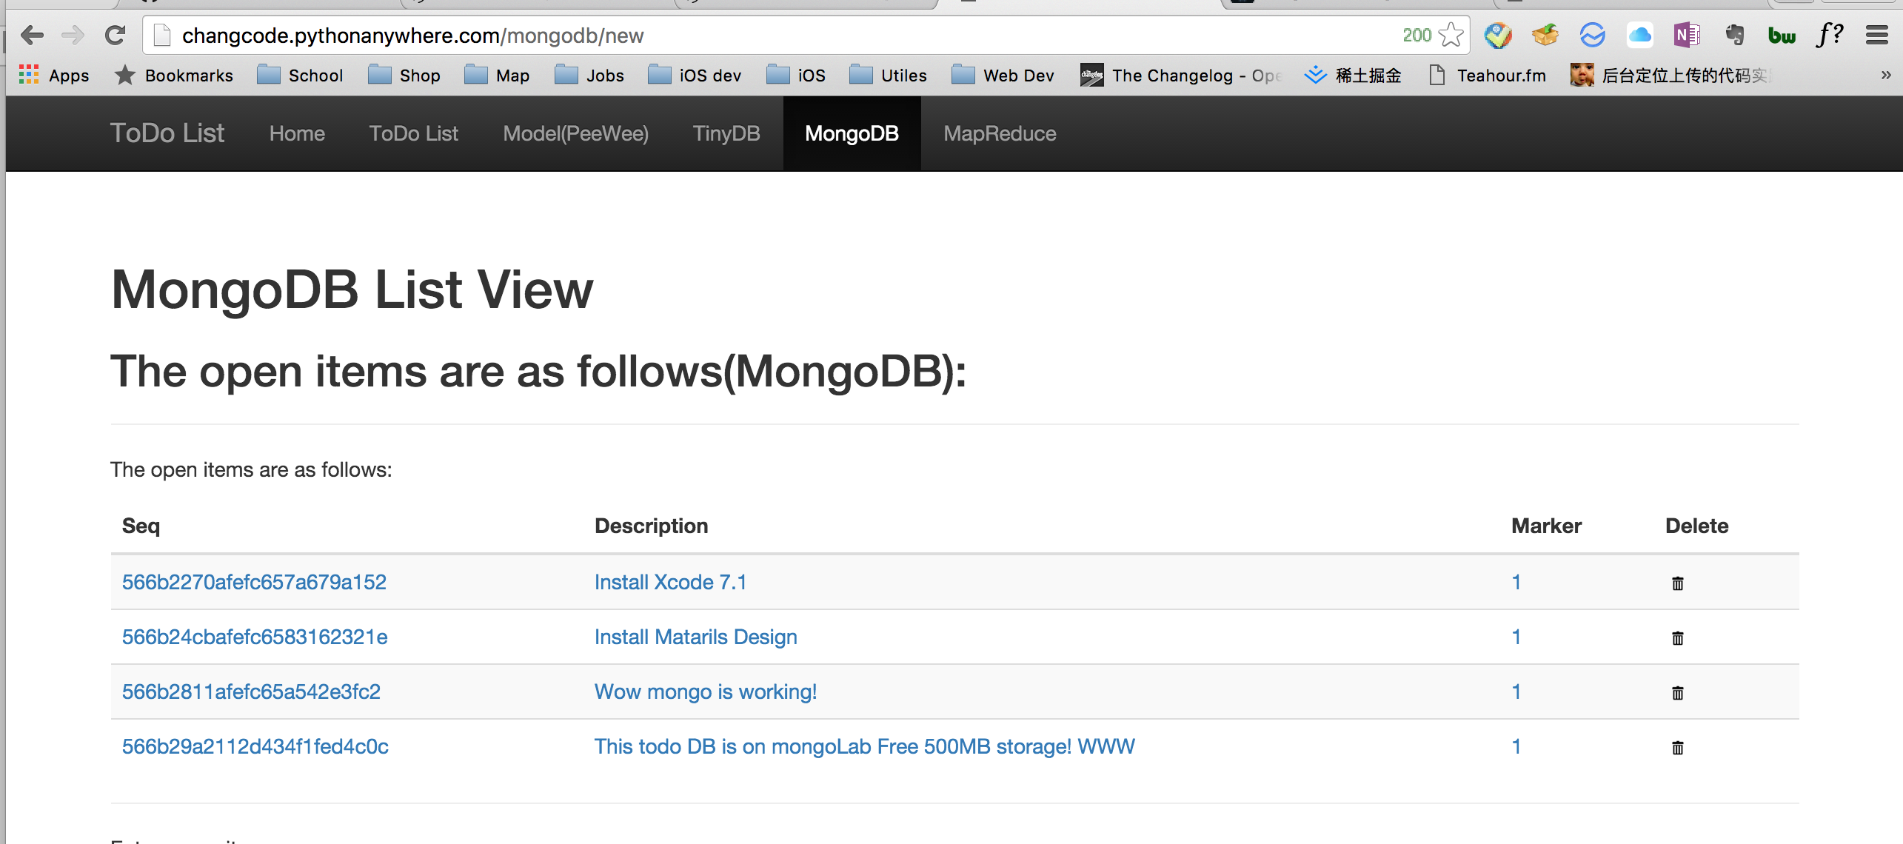

Local:

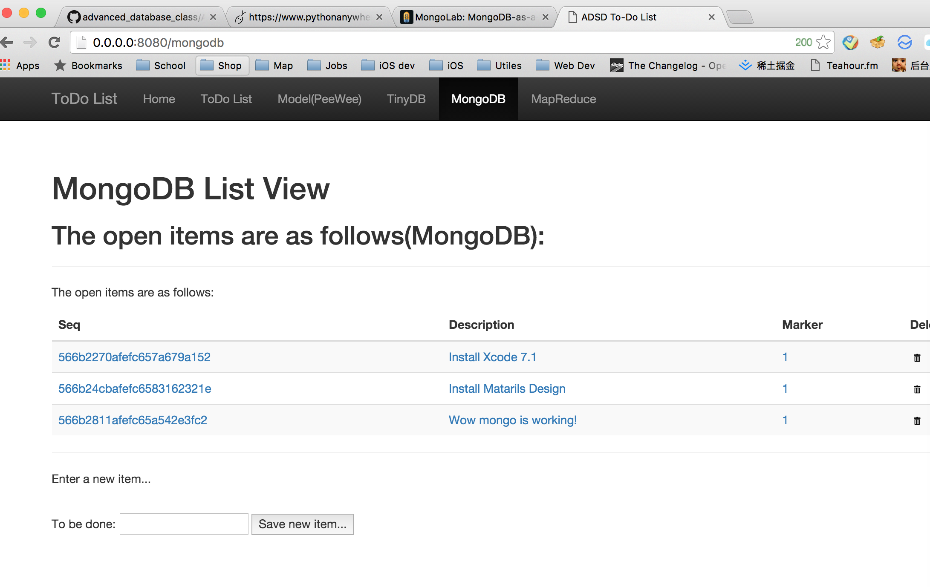

Code:

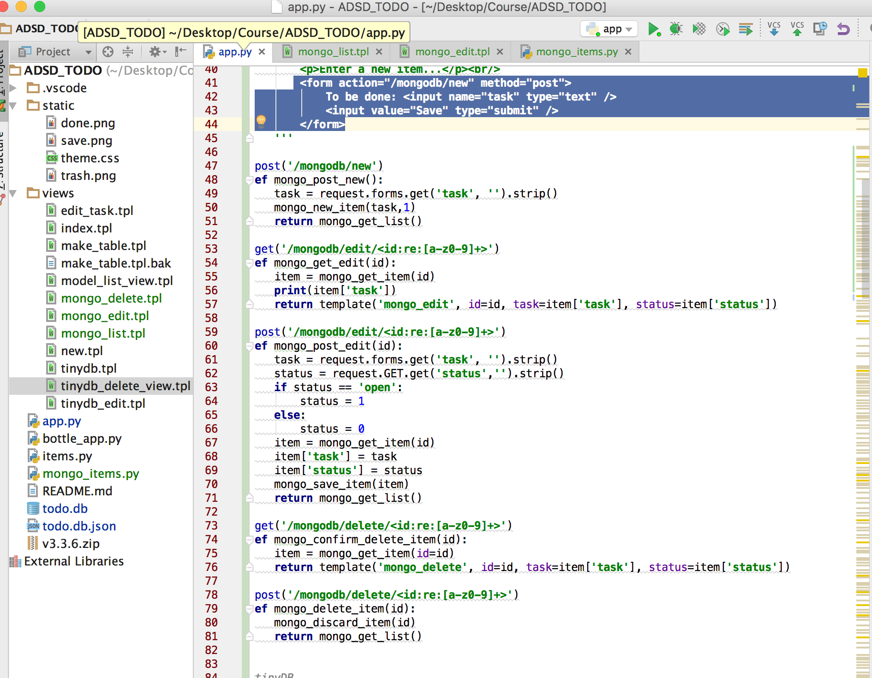

MongoDBItems:

